**Technical Memorandum 4.3: Faculty/Staff Modeling Additions to University Model**

|  |  |
| --- | --- |
| **Prepared for:**  University Model Development Team |  |
| **Prepared by:**  Parsons Brinckerhoff  400 SW 6th Ave, Suite 802 Portland, Oregon 97204 | **PB Logo RGB.jpg** |

**June 2014 (Final)**

Table of Contents

Introduction 3

Model Components 3

Survey Data Processing 3

Faculty/Staff Survey Data 3

Faculty and Staff Models 4

Worker Location Model 4

Work Tour Destination Choice Model 6

Tour Frequency Models 7

Tour Time-of-Day Choice 7

Intermediate Stop Frequency Model 8

Intermediate Stop Purpose Model 9

University Model User’s Guide 9

Input Files 9

New Output Files 10

Table of Tables

Table 1: Faculty/Staff Tour Frequency Inputs 7

Table 2: Faculty/Staff Intermediate Stop Frequency Inputs 8

Table 3: Faculty/Staff Intermediate Stop Purpose Model Inputs 9

Table 4: New UEC and Probability Distribution Files 10

Table of Figures

Figure 1: Home to University Distance Frequency Distribution 5

Figure 2: Distance Frequency Distribution for Worker Residential Location Choice Model 6

Figure 3: Tour Length Frequency Distribution for Faculty/Staff Work Tours 7

Figure 4: Faculty/Staff Work Tour Time of Day Distribution 8

# Introduction

This memorandum describes the addition of a faculty\staff segment to the Major University Travel Model developed for the Oregon Department of Transportation. The previous model, which was based upon a survey of University of Oregon students, only addressed student travel patterns. However, the model is being extended to consider parking constraints at Oregon State University. In order to comprehensively model parking policy, it was necessary to add faculty and staff travel to campus. The University of Oregon Travel Survey included travel data for faculty and staff in addition to the student records used to estimate the original models. The faculty and staff travel records provided sufficient data to develop a residential location choice model for university faculty and staff workers as well as other model inputs specific to faculty and staff.

Although the University of Oregon Travel Survey included some data for faculty and staff, the number of records was much smaller than the number of student records, and the majority of the faculty/staff records were for work tours to and from the university. Due to the lack of data and the fact that the modeling effort is primary focused on travel to and from the university campus, only work tours were included in the models for faculty and staff. The tour frequency inputs were generated assuming only work tours, although the work tour frequency model takes into account the probability of making more than one work tour during the day.

## Model Components

The faculty/staff travel model functionality copies the student travel model in every way except for residential location choice. Tour and trip decisions for faculty and staff are made in the same way as they were in the student model. The tour frequency, tour time of day, stop frequency, and stop purpose components were modified to allow for separate distributions for faculty and staff travel. The auto ownership and mode choice models were also updated to allow for faculty/staff calibration constants to allow the user to calibrate the faculty/staff choices separately from students.

# Survey Data Processing

## Faculty/Staff Survey Data

In order to develop the required input files for the faculty and staff models, the University of Oregon Travel Survey data for faculty and staff were processed into tours. Once those tours were created from the survey, the corresponding tour and stop frequency distributions as well as time of day distributions and other factors were generated.

The University of Oregon Travel Survey included 365 weekday Faculty/Staff records . Of those records, only 306 provided a home location within the LCOG study region. Those 305 faculty/staff records were kept in the input files, and their reported travel data was processed into tours. The tour processing procedure was performed without cleaning the data to estimate missing times or add missing home locations at the beginning or end of a tour. Therefore, records that had travel data but could not be processed into tours had to be removed from both the person and tour records before the model inputs were created to ensure that they were not falsely counted as a household that made no tours.

The output of the tour processing included tour records for 232 faculty/staff members as well as 32 faculty/staff members who made no tours during the survey day. Those 264 faculty/staff records were used to generate tour frequency, tour time of day, stop frequency, and stop purpose input files for the faculty/staff model. These data were simplified, however, to only include work tours since those are the primary tour of interest for university faculty and staff. The results of this processing and the model inputs developed from the survey are shown in more detail in the Faculty and Staff Models section.

# Faculty and Staff Models

The University of Oregon travel survey was used to provide the faculty/staff input files for some model components as well as to calibrate other model components. Faculty/staff travel patterns differ noticeably from students in tour and stop purpose and frequency distribution as well as the time of day distribution.

## Worker Location Model

### Model Development

The worker location choice model was developed to select workers (faculty and staff) from the synthetic population. The worker location choice model is run after the population synthesis is complete, and it uses the workers already generated in the population synthesis. It is essentially a work location choice model but it is run in reverse from the typical application. In the typical application, each worker chooses a work location based upon their attributes (worker occupation and/or income, residential location, etc) and the attributes of the potential work locations (employment by type, accessibility, etc.). In the university worker location choice model, the general work location (the major university location) and total university faculty\staff workers is known, and workers are drawn from the synthetic population.

The worker location choice model is based upon the total workers in the synthetic population in each TAZ, and the distance between the TAZ and the university (using university reference TAZ 398). Each TAZ is assigned a probability of containing workers who work at the university, and a worker is then sampled from the total workers that reside in that TAZ in the synthetic population according to that probability.

The first stage of the procedure is to generate csv file called workersByOccupationAndTAZ which summarizes the number of workers in each TAZ in the synthetic population in seven occupation categories: 1) Management, Business, Science, and Arts, 2) White Collar Service Occupations, 3) Blue Collar Service Occupations, 4) Sales and Office Support, 5) Natural Resources, Construction, and Maintenance, 6) Production, Transportation, and Material Moving, and 7) Military. Workers who work in the Natural Resources, Construction, Maintenance, Production, Transportation and Material Moving and Military occupation categories are not considered by the major university model as potential candidates for working at the major university. The count of total workers in the remaining categories becomes the size term for the TAZ. The distance term in the utility calculation is the same as in the off-campus family student residential location choice calculations, because the survey shows that the distance frequency distribution for faculty and staff members is more similar to the off-campus family students in the survey data than the non-family students (Figure 1).

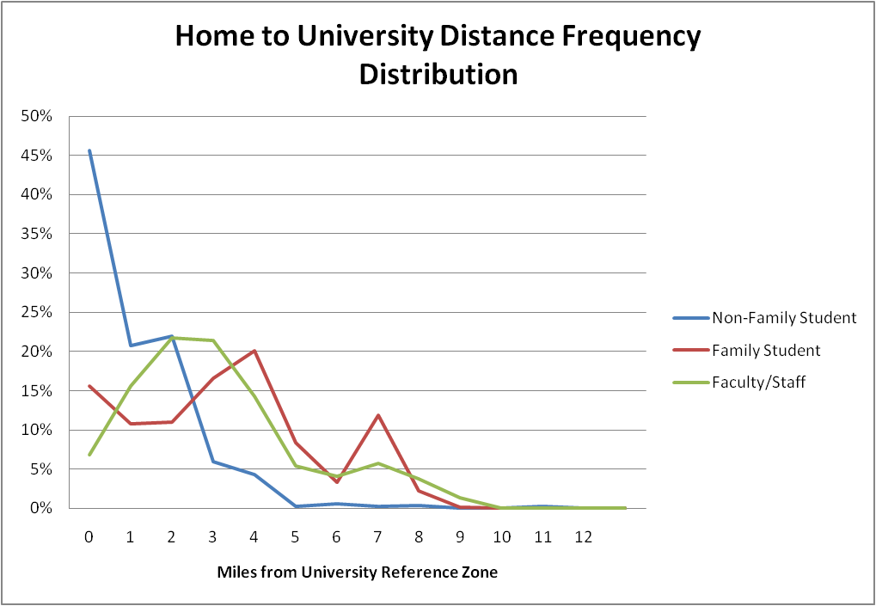

Figure 1: Home to University Distance Frequency Distribution

The model iteratively selects a worker from the synthetic population according to the probability distribution of the TAZ and the total number of qualifying workers in that zone, until the number of selected workers equals the total faculty\staff count for the major university.as specified in the properties file. The report file also indicates how many major university workers were selected in each TAZ.

Due to the fact that working students were found to have different tour and trip-making patterns than non-student university workers, workers already identified as also being major university students are not included as possible faculty/staff. Students can still work at the university, but they are modeled as students with a university TAZ as their workplace location. The controls set in the properties file to specify the number of faculty/staff members also exclude students working for the university.

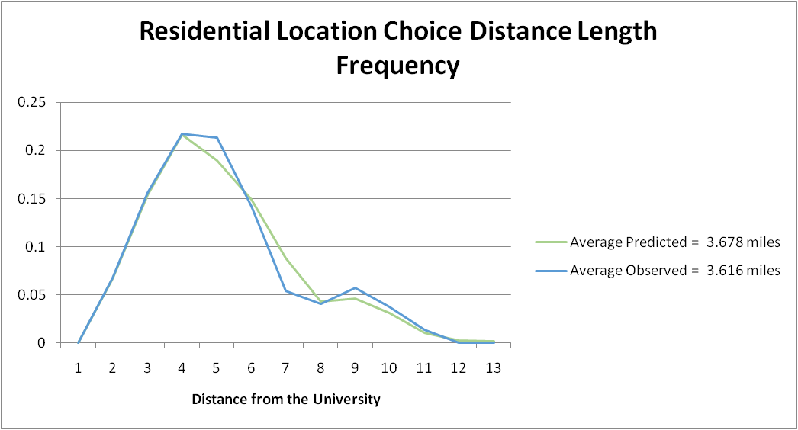The final implementation of the worker residential location choice model resulted in the distance frequency distribution shown in Figure 2. The final implemented model matched the distance frequency distribution seen in the survey for most distance categories with slight differences in some of the higher distance categories.

Figure 2: Distance Frequency Distribution for Worker Residential Location Choice Model

## Work Tour Destination Choice Model

### Model Development

The work tour destination choice model for faculty/staff uses the previously-developed university tour destination choice model for students. This model selects the tour destination based on the usable square feet of university classroom space in each zone. Due to the fact that the worker location choice model locates faculty/staff members based on the distance between their home and the university, the work tour destination choice model required closely fit the work tour length frequency distribution without any calibration. Figure 3 shows the tour length frequency distribution for work tours for major university workers.

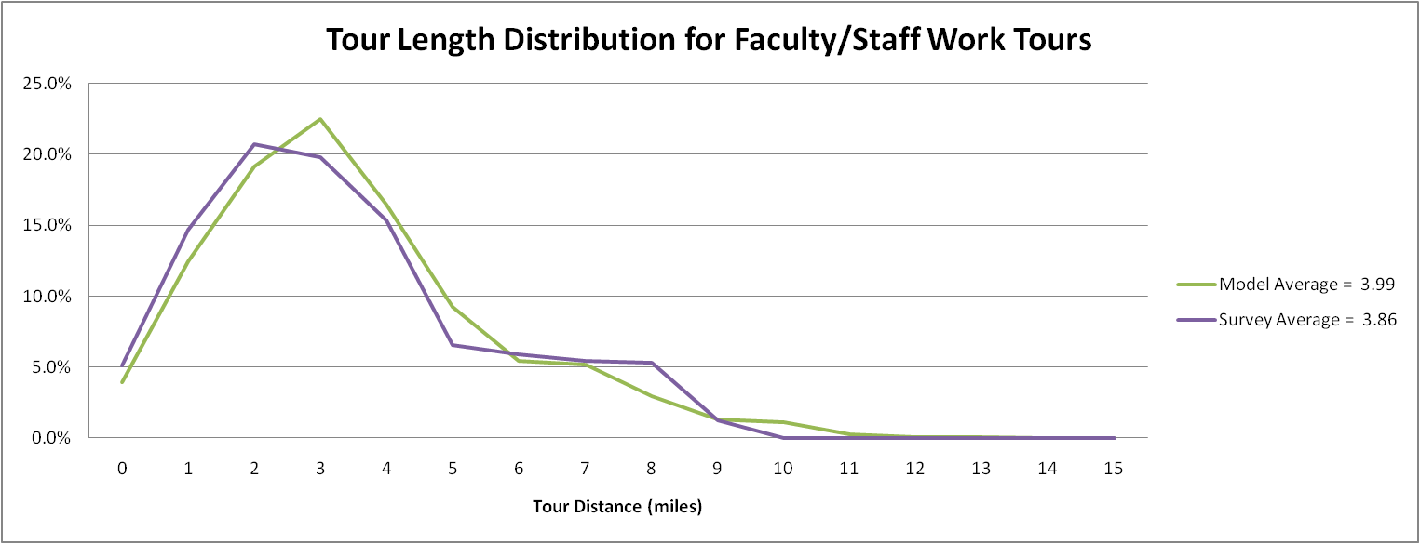

Figure 3: Tour Length Frequency Distribution for Faculty/Staff Work Tours

No other tour purposes were included in this model for faculty/staff members.

## Tour Frequency Models

The tour frequency model inputs were changed so that faculty/staff and student tour frequencies are provided separately. The faculty/staff tour frequencies were calculated based on the processed tour data from the University of Oregon survey. The tour patterns were simplified, however, to only check for the number of work tours performed during the survey day. The resulting tour frequency input file is provided in Table 1.

Table 1: Faculty/Staff Tour Frequency Inputs

|  |  |  |  |  |  |
| --- | --- | --- | --- | --- | --- |
| **Worker** | **Work Tours** | **University Tours** | **Maintenance Tours** | **Discretionary Tours** | **Frequency** |
| Yes | 0 | 0 | 0 | 0 | 0.189394 |
| Yes | 1 | 0 | 0 | 0 | 0.765152 |
| Yes | 2 | 0 | 0 | 0 | 0.045455 |

The travel survey showed that on an average weekday approximately 81% of non-student major university workers made at least one work tour. That number is much higher than the student tour frequencies, where only 19% workers in the Group Quarters category, 21% of workers in the Non-Family Off-Campus category, and 30% of workers in the Family Off-Campus category made at least one work tour during the day.

## Tour Time-of-Day Choice

The tour time-of-day choice model inputs were also modified to match the survey results for faculty and staff. While student work tours were distributed throughout the day, the faculty/staff work tour time of day distribution showed much more peaking around 7:00 am for departure from home to work and 5:00 pm for arrival back at home. The work tour time of day distribution for faculty and staff is shown in Figure 4.

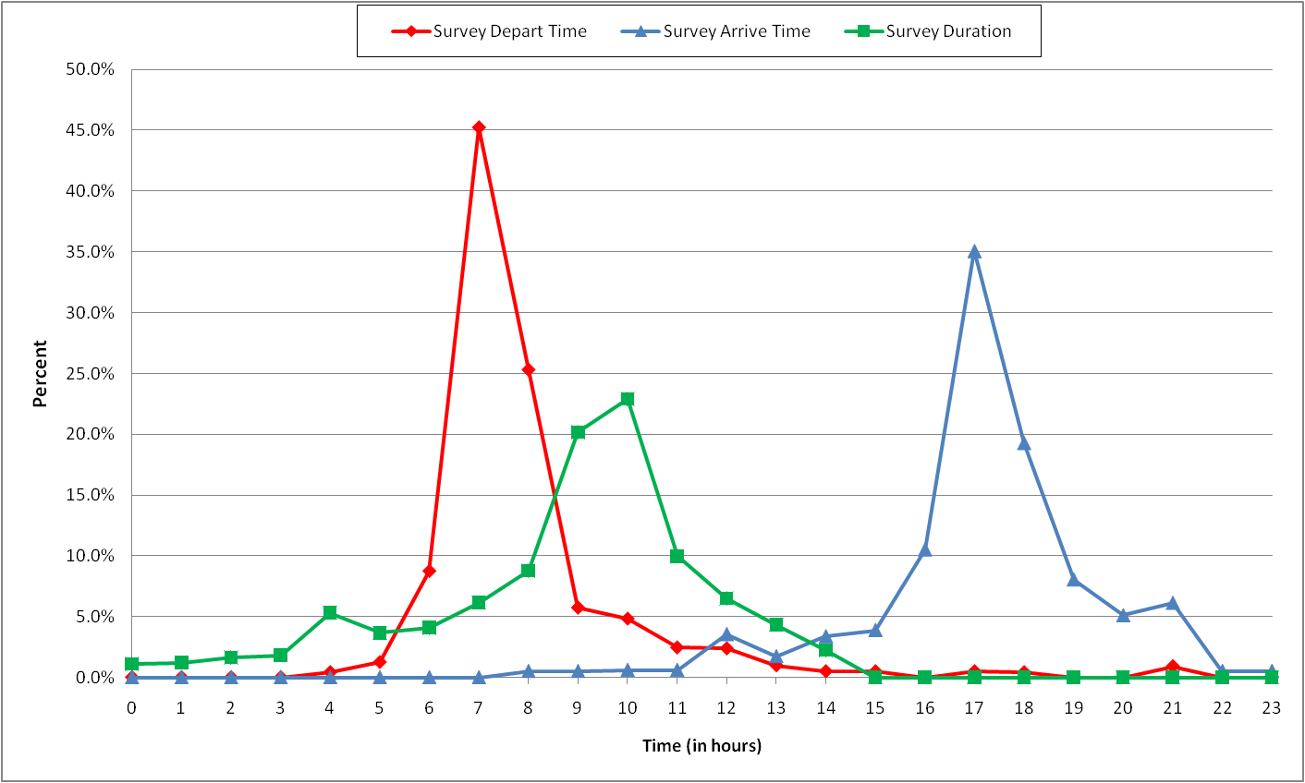

Figure 4: Faculty/Staff Work Tour Time of Day Distribution

Based on the time of day distribution provided by the survey data, a faculty/staff tour time of day frequency file was generated to match the observed distribution for work tours.

## Intermediate Stop Frequency Model

The intermediate stop frequency model inputs were also generated for university faculty and staff as a separate input file. For shorter work tours, faculty/staff and students had similar frequencies for making no stops, but for longer tours, the faculty/staff survey results generally showed a higher percentage of users making no stops. The values from the faculty/staff stop frequency input file are shown in Table 2.

Table 2: Faculty/Staff Intermediate Stop Frequency Inputs

|  |  |  |  |  |  |
| --- | --- | --- | --- | --- | --- |
| **Stop Pattern** | **Tour Duration** | | | | |
| **0 – 2 hours** | **2 – 4 hours** | **4 – 8 hours** | **8 – 12 hours** | **12 – 24 hours** |
| 0 Out, 0 In | 77% | 65% | 85% | 56% | 39% |
| 0 Out, 1 In | -- | 35% | 6% | 21% | 35% |
| 0 Out, 2 In | -- | -- | 0% | 10% | 4% |
| 0 Out, 3 In | -- | -- | 3% | 2% | 4% |
| 1 Out, 0 In | 22% | -- | 3% | 5% | 6% |
| 1 Out, 1 In | -- | -- | -- | 3% | 9% |
| 1 Out, 2 In | -- | -- | 3% | 1% | -- |
| 1 Out, 3 In | -- | -- | -- | -- | -- |
| 2 Out, 0 In | -- | -- | -- | 1% | 3% |
| 2 Out, 1 In | -- | -- | -- | 1% | -- |
| 2 Out, 2 In | -- | -- | -- | -- | -- |
| 2 Out, 3 In | -- | -- | -- | -- | -- |

## Intermediate Stop Purpose Model

An input file for the university faculty/staff intermediate stop purpose model was also created based on the faculty/staff survey data. This model specifies the frequency with which a stop is made for each purpose (Work, University, Maintenance, or Discretionary) based on the tour purpose, whether the stop is inbound or outbound, the stop number, and whether there are other inbound or outbound stops on the tour. For the university faculty/staff model only work tours are generated, so the intermediate stop purpose inputs only included data for work tours. The maximum stop number in the input file was also limited to the maximum observed stop number in each category. The frequencies used in the input file for the faculty/staff intermediate stop purpose model for work tours are shown in Table 3.

Table 3: Faculty/Staff Intermediate Stop Purpose Model Inputs

|  |  |  |  |  |  |  |
| --- | --- | --- | --- | --- | --- | --- |
| **Inbound Stop** | **Stop Number** | **Multiple Stops** | **Stop Purpose** | | | |
| **Work** | **University** | **Maintenance** | **Discretionary** |
| 0 | 1 | 0 | -- | -- | 57.92% | 42.08% |
| 0 | 1 | 1 | -- | -- | 45.88% | 54.12% |
| 0 | 2 | 1 | -- | -- | 50.00% | 50.00% |
| 1 | 1 | 0 | 6.78% | -- | 54.11% | 39.12% |
| 1 | 1 | 1 | 4.37% | -- | 72.23% | 23.41% |
| 1 | 2 | 1 | -- | -- | 63.49% | 36.51% |
| 1 | 3 | 1 | -- | -- | 48.55% | 51.45% |

# Faculty/Staff Model User’s Guide

The overall setup and process of running the university model remains the same. The only changes are to the input files required by the model and the set of output files produced by the model. This section describes the changes to both the input and output files to allow for the modeling of faculty/staff travel.

## Input Files

There were some modifications required to the inputs and settings of the model to allow for the modeling of faculty/staff travel separately from student travel. This section describes the changes made to the following sets of inputs: Model Specifications and Property Files.

#### Changes to Model Specifications

The modifications to the University model that allowed for faculty/staff-specific inputs required modifying the old specification and instead providing probability distributions specific to each market segment (Faculty/Staff or Students). The new model specifications are listed in Table 4 in order of use by model component.

Table 4: New UEC and Probability Distribution Files

|  |  |
| --- | --- |
| **UEC File** | **Description (UEC file for)** |
| UniversityWorkerResidentialChoice.xls | Worker residential location choice full model UEC |
| UniversityTourFrequencyFacultyStaff.csv | University tour frequency distribution for university faculty and staff |
| UniversityTourTimeOfDayDistributions_FacultyStaff.csv | Observed probability distributions for university tour time-of-day choice for university faculty and staff |
| UniversityTourTimeOfDayDistributions_Student.csv | Observed probability distributions for university tour time-of-day choice for university students |
| UniversityStopFrequencyDistributions_Student.csv | University Stop Frequency Distributions by tour purpose, duration, and number of inbound/outbound stops for university students |
| UniversityStopFrequencyDistributions_FacultyStaff.csv | University Stop Frequency Distributions by tour purpose, duration, and number of inbound/outbound stops for university faculty and staff |
| UniversityStopPurposeDistributions_Student.csv | University Stop Purpose Distributions by tour purpose, inbound stop, stop number, multiple stops on tour indicator for university students |
| UniversityStopPurposeDistributions_FacultyStaff.csv | University Stop Purpose Distributions by tour purpose, inbound stop, stop number, multiple stops on tour indicator for university faculty and staff |

#### Changes to Property Files

The properties file had to be modified to allow the model to read in separate input files for faculty/staff and students. The file was modified to include property maps for all of the files shown in Table 4 so that the correct inputs would be applied to each market segment. A field was also added to the tpau_tbm.properties file to specify the number of university faculty/staff workers that should be modeled. The worker residential location choice model uses that property to define the number of major university workers to be generated.

## New Output Files

There were two changes made to the output files related to the faculty/staff model functionality. The first was the addition of the majoruniversityworker field in the persons.csv output file. This field indicates whether the person is a member of the faculty or staff at a major university. The field is set to 1 for university faculty/staff and set to 0 otherwise.

The other modification to outputs is the creation of the workersByOccupationAndTAZ.csv output file. This file lists the number of workers in each of the six occupation categories by TAZ based on the input population. This file is written out and used by the faculty/staff worker residential location choice model.